INSTRUCTIONS FOR CIRCULATING PETITIONS
We need 15,000 VALID signatures. There is no set deadline at this point, according to PA 233 of 1955, but they should be collected as quickly as possible. We should collect about twice that number to ensure validation by the City Clerk.

- ALL SIGNERS must be residents of the city of Detroit, and registered voters. Ask if they are both before they sign. Be sure they insert the date they are signing, as well as “Detroit” in col. 1.

- CIRCULATORS DO NOT HAVE TO BE CITY OF DETROIT RESIDENTS. Please complete the Circulator’s Certificate at lower right hand side AFTER all signers have signed.

- RETURN COMPLETED PETITIONS and GET MORE:
- Call 313-649-7018 or 313-825-6126 to have them picked up or to have more delivered. DAREA, one member of the Coalition to Save Detroit’s Water & Sewerage Dept., meets the first Wed. of every month at St. Matthew & St. Joseph Episcopal Church, 8850 Woodward Ave. at Holbrook, Detroit, MI 48202. It holds committee meetings the third Mon. of every month at Nandi’s Knowledge Café 12511 Woodward Ave. Highland Park, MI 48203. Campaign updates given.
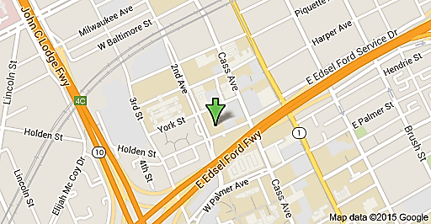
- You can return them yourself by going to the office of Moratorium NOW! at 7 pm each Monday. It is located at 5920 Second Avenue at Antoinette, south of West Grand Blvd, north of Wayne State University. Moratorium NOW! holds its weekly meetings at that time. Campaign updates given.

- TALKING POINTS:

- This is A SALE, NOT A LEASE, of ALL PERSONAL PROPERTY AND REVENUES of the $6 billion Detroit Water & Sewerage Department (DWSD), Detroit’s largest asset.
- The Authority can also SELL DWSD REAL PROPERTY, an opportunity for PRIVATIZATION.
- It is a THEFT by an unelected state-controlled authority established by Gov. Rick Snyder and former Detroit EM Kevyn Orr during the Detroit bankruptcy.
- INCREASED RATE HIKES for Detroiters and residents of ALL six counties in DWSD—Wayne, Oakland, Macomb, St. Clair, Lapeer, Genesee, Washtenaw and Monroe will occur.
- WATER SHUT-OFFS not only for Detroiters, but residents of all six counties possible.
- WATER BILLS ADDED TO DETROIT TAX BILLS—authority can extend that practice.
- Only Detroiters can sign the petition because the City of Detroit, as owner of DWSD, is the only party to the contract with the GLWA.
- Under Public Act 233 of 1955, the people of the municipality contracting with the authority are authorized to hold a REFERENDUM VOTE on the contract. If the vote is NO, the contract must be CANCELED.

Sponsored by the Coalition to Save Detroit’s Water & Sewerage Dept. #OurWaterOurVote
Call 313-649-7018 or 313-825-6126

