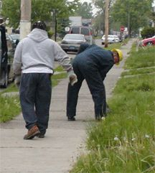
Crews shutting off water at residence in 2007

