Kilpatricks and Conyers among 8 named in FBI bribery probe

12:12 PM, Jan. 28, 2009 |
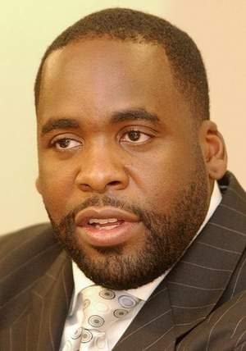
BY DAVID ASHENFELTER, M.L. ELRICK, JOE SWICKARD AND JIM SCHAEFER
FREE PRESS STAFF WRITERS
- Former Detroit Mayor Kwame Kilpatrick, his father, Bernard Kilpatrick, and City Council President Monica Conyers are the major figures cited in a sludge-hauling executive's account of greed and bribery in the Synagro scandal, sources confirmed Tuesday to the Free Press. The three have not been charged with wrongdoing in the case.
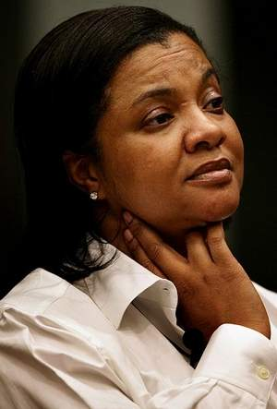
Their names -- and others -- emerged with additional details about the government's investigation into city corruption.
The Free Press has learned that James Rosendall, the former Synagro Technologies vice president who pleaded guilty to bribery Monday, has been questioned about his contacts with other executives at Houston-based Synagro.
FBI agents recorded one Synagro official on a phone call with Rosendall discussing Rosendall's efforts to win the $1.2-billion contract in Detroit, one source said, adding that executive has since been suspended by Synagro.
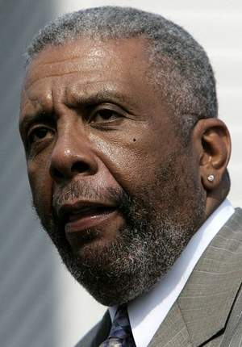
Rosendall, 44, of Grand Rapids is the government's star witness in the Synagro probe and has provided the FBI with little, if any, direct evidence that cash was funneled to Kwame Kilpatrick, according to sources familiar with the case.
One source also said that Kilpatrick's jailed former chief of staff and lover, Christine Beatty, does not appear to be a target of the Synagro probe.

Other figures named
In addition to the Kilpatricks and Monica Conyers, the Free Press has identified five other people who were cited -- but not named -- in Rosendall's plea records Monday.
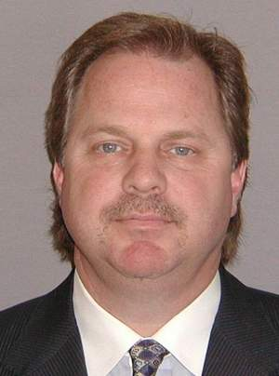
Sources identified those five as onetime mayoral aides Michael Tardif and Derrick Miller; Detroit developer and Synagro consultant Rayford Jackson; Akunna Olumba, a business associate and former girlfriend of Bernard Kilpatrick, and former Conyers aide Sam Riddle.
They all declined to comment or could not be reached Tuesday, though Riddle just told WXYZ-Channel 7 he did not funnel Synagro money to Conyers, as the plea agreement alleges. “I was not that intermediary and I did not have that conversation with Rosendall,” Riddle told reporter Steve Wilson. Referring to today’s Free Press report, Riddle called the newspaper’s headline “misleading.”
Acting U.S. Attorney Terrence Berg wouldn't confirm any identities Tuesday, repeating his view that it's improper to link people to possible crimes if they have not been charged.
"You shouldn't accuse people until you're prepared to go into court and back it up," Berg said.
A lawyer for Kwame Kilpatrick declined to comment Tuesday.
Bernard Kilpatrick, who runs a Detroit consulting firm, "absolutely" denied he was the Relative A to City Official A cited in Rosendall's plea deal.
"That was a blatant lie," he said of the plea document, which contends that Rosendall paid him $25,000 to help win the 2007 Synagro contract.
Conyers wouldn't discuss Rosendall's plea deal.
"Why don't you ask the other people?" she told a reporter after a meeting Tuesday. She previously has said she has nothing to fear from the federal investigation, which also extends to other city contracts and business deals.

Time is running out
The identities of the eight individuals emerged Tuesday as legal experts debated why federal prosecutors described the eight with names such as City Official A, Relative A and City Council Member A.
Most experts interviewed Tuesday said Rosendall's highly detailed 18-page plea agreement sends a clear message that time is running out for anyone who participated in the conspiracy but who so far has refused to cooperate.
"The window of opportunity to cooperate with the government will only be open for a short time, and whoever comes in first will get the best deal," said Detroit criminal lawyer David Griem.
In a related development, a Synagro spokesperson confirmed that Rosendall was fired Tuesday from his job as the company's Michigan vice president. He had been suspended since last summer when the scandal broke.
Rosendall pleaded guilty Monday to a single count of bribery conspiracy, a deal that will likely require him to spend 11 months in prison and pay a fine up to $250,000.
After the FBI confronted Rosendall with evidence early last year, he cooperated with its investigation by helping agents record conversations and alleged payoffs with city employees and others.
Cooley Law School professor Alan Gershel, former head of the U.S. Attorney's Criminal division, said he was surprised by the amount of information contained in the documents released Monday in connection with Rosendall's plea, saying they usually don't have as much detail.
Mayer Morganroth, the lawyer who represented Beatty in the text message scandal, said the government's high-profile tactics could be putting the squeeze on people who will have to decide soon between becoming witnesses or defendants.
"Maybe one of them will see the information and say, 'I better get myself in there.' "
Contact DAVID ASHENFELTER at dashenfelter@freepress.com. Staff writer Zachary Gorchow contributed to this report.

