VOICE OF DETROIT http://voiceofdetroit.net
Editor Diane Bukowski, Videographer Kenneth Snodgrass P.O. Box 32684 Detroit, MI 48232
Direct Line: 313-825-6126 Direct Fax: 313-557-1576 email: diane_bukowski@hotmail.com

SIGN PETITION TO REQUEST US DOJ FRAUD INVESTIGATION OF UBS RE:

PREDATORY $1.5 BILLION DETROIT LOAN
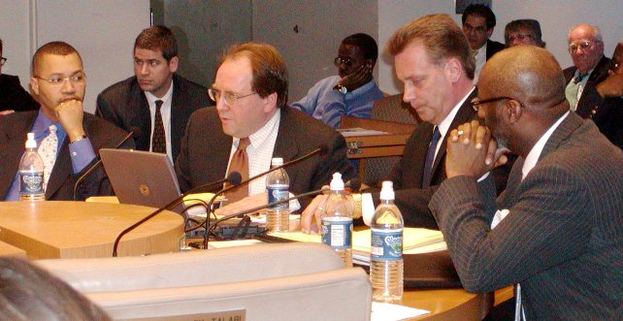
PREDATORY LENDING: Jan. 31, 2004: Wall Street ratings agenices reps Joe O’Keefe of Fitch Ratings (speaking), and Stephen Murphy of Standard and Poor’s (to his left), foisted $1.5 BILLION loan on city of Detroit. Also shown in photo (l) then Detroit CFO Sean Werdlow, who left the Kilpatrick administation later that year to take a job with UBS ‘minority partner Siebert, Brandford & Shank as managing director, and (r) then Deputy Mayor Anthony Adams. Photo by Diane Bukowski
VOD requested investigation by USDOJ, no response yet
By Diane Bukowski July 3, 2013
Voice of Detroit has submitted the following request to the U.S. Department of Justice for a criminal fraud investigation related to the 2005 $1.5 Billion Pension Obligation Certificates loan UBS AG CEO Sergio Ermatti to the City of Detroit from bankers UBS AG and Siebert, Brandford and Shank. UBS AG has already paid $1.5 billion in fines to the USDOJ related to the LIBOR interest-rate rigging scandal. Additionally, executives from UBS/Japan have been criminally charged. The events detailed in this letter are similar to those which forced Chase Bank to forego 70 percent of the debt owed to it by Jefferson County, Alabama in their Chapter 9 bankruptcy filing. To date, we have received no response.

We have started a petition on Change.Org at http://www.change.org/petitions/jeffrey-knox-usdoj-criminal-fraud-division-investigate-criminal-bank-ubs-ag-for-predatory-1-5-billion-loan-to-detroit. Please click link and sign.
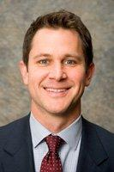
Jeffrey Knox/Denis J. McInerney, Chief Fraud Section and Daniel Braun, Deputy Chief
June 26, 2013
U.S. Department of Justice, Criminal Division Fraud Section
Bond Building, 4th Floor
10th and Constitution Ave. NW
Jeffrey Knox Washington, DC 20530-0001
RE: POSSIBLE ADDITIONAL CRIMINAL FRAUD BY UBS AG ET. AL.
To Mr. Knox/McInerney and Mr. Braun, or others currently in place in the Fraud Section of the US DOJ Criminal Division:
I have reviewed your documents on the USDOJ website relating to agreements between the U.S. Department of Justice and UBS AG/UBS Japan, regarding the $1.5 billion fine exacted from UBS and criminal prosecutions of its executives, related to criminal fraud charges.

I am requesting, both as a newspaper editor and as a City of Detroit retiree who may have been adversely affected by possible criminal fraud perpetrated by UBS AG on the City of Detroit and its investors nationally, that your division launch an investigation into the following matters:

On Jan. 31, 2005, the UBS AG and its minority partner, Siebert, Brandford & Shank, now known as SBS Financial, came to the Detroit City Council to obtain approval of a so-called “Pension Obligation Certificates” loan in the amount of $1.2 billion. The City Council approved that loan the next month after considerable controversy.
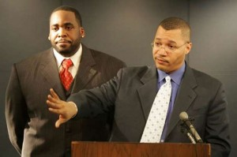
At the time, Detroit’s Mayor was Kwame Kilpatrick, now serving time due to federal charges on other matters, and its Chief Financial Officer was Sean Werdlow. Werdlow was at the Council table advocating for the loan on behalf of Kilpatrick. Later that year, Sean Werdlow took a top manager position with Siebert, Brandford and Shank (now SBS Financial). He remains in that position to date.
Former Detroit Mayor Kilpatrick, CFO Werdlow
Also at the City Council table advocating for the loan were Stephen Murphy of Standard & Poor’s and Joe O’Keefe of Fitch Ratings. They essentially backed the administration’s position that if the loan did not go through, the city would face massive lay-offs, and that its bond ratings would be downgraded. I am aware that the Justice Department has also sued Standard & Poor’s in another matter.

In 2009, the City of Detroit defaulted on that loan, after the global economic collapse of 2008. To avoid paying the loan in total, its then Mayor Kenneth Cockrel, Jr. agreed to have the taxes collected from the city’s three casinos routed through a trustee, U.S. Bank NA, to ensure payment of the debt. I am not aware of any reports issued by U.S. Bank NA recounting how it has distributed those funds. I am aware that the Securities and Exchange Commission has filed suit against U.S. Bank NA in another matter related to the collapse of Peregrine Financial.

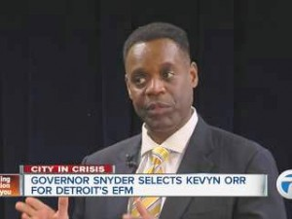
On June 14, 2013, City of Detroit Emergency Manager Kevyn Orr announced deliberate non-payment of $39.7 million due on the UBS loan that day. In a “Proposal to Creditors” issued that day, Mr. Orr stated, ‘The City has identified certain issues related to the validity and/or enforceability of the COPS that may warrant further investigation,” referring to the UBS AG loan as “Certificates of Participation,” another term for “Pension Obligation Certificates.” Standard and Poor’s and the other ratings agencies further downgraded the City’s bond ratings to the lowest of any major city in the country, creating further harm to the City and its investors
.
Since the U.S. Justice Department, Criminal Fraud Division has found UBS guilty of fraud related to the LIBOR scandal (which likely also affects the City of Detroit), I am requesting that your office launch an investigation into:
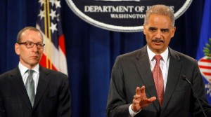
UBS AG’s actions in the City of Detroit Pension Obligation Certificates loan.
The related actions of City officials including Kwame Kilpatrick and Sean Werdlow.
The actions of Standard and Poor’s and Fitch in advocating for that loan, which appear to have constituted a gross conflict of interest.
Atty. General Eric H. Holder Jr., (r) and the actions of Emergency Manager Lanny A. Breuer announce charges vs. UBS Kevyn Orr and the city’s “debt re-structuring” consultants, the Jones Day law firm, in deliberately withholding payment on the UBS loan as part of an overall strategy outlined in their Proposal to Creditors.

I have attached or linked various articles and documents related to this matter. I look forward to hearing from you in an expeditious manner. My contact information is below.

Sincerely,
Diane Bukowski
Editor, Voice of Detroit, LLC
City of Detroit retiree
Attached: Linked articles as below

http://voiceofdetroit.net/2013/06/20/em-orrs-plan-for-detroit-phony-debt-moratorium-theft-of-city-assets-including-water-belle-isle-pensions/

http://voiceofdetroit.net/2013/06/13/public-pensions-could-be-targeted-in-chapter-9-bankruptcy-pending-court-rulings/

http://voiceofdetroit.net/2013/05/16/detroit-em-orrs-report-envisions-a-nightmare-future/

http://voiceofdetroit.net/2013/05/09/people-demand-moratorium-on-detroit-debt-reparations-as-em-readies-attack/

http://voiceofdetroit.net/2013/04/08/costly-jones-day-em-contract-faces-council-vote-tues-apr-9-come-at-9-am/

http://voiceofdetroit.net/2013/04/08/only-wall-street-wins-in-detroit-crisis-reaping-474-million-fee/

http://voiceofdetroit.net/2013/03/31/detroit-council-to-vote-on-jones-day-contract-firm-represents-criminal-banks-holding-citys-debt/
http://voiceofdetroit.net/2013/03/19/wall-street-v-woodward-ave-will-detroit-em-address-predatory-interest-rate-swaps/

http://voiceofdetroit.net/2013/03/17/detroit-efms-law-firm-advises-worlds-biggest-crooks-including-libor-banks/

http://voiceofdetroit.net/2013/02/24/u-s-banks-scrutinized-in-libor-scandal-probe/

http://voiceofdetroit.net/2013/02/06/usdoj-slams-standard-poors-with-5-billion-fraud-lawsuit/

http://voiceofdetroit.net/2012/12/19/ubs-admits-fraud-in-1-5-billion-libor-rigging-settlement/

http://voiceofdetroit.net/2012/09/27/detroit-dwsd-debt-shows-wall-street-never-loses-on-bad-swaps/

http://voiceofdetroit.net/2012/07/23/detroit-cut-2-billion-pension-bond-deal-with-ubs-one-of-banks-sued-by-baltimore-others-in-libor-scandal/

http://voiceofdetroit.net/2011/12/19/11652/

http://voiceofdetroit.net/2011/05/03/detroit-pension-systems-file-federal-suit-against-pa-4-broad-coalition-also-expects-to-take-legal-action/

