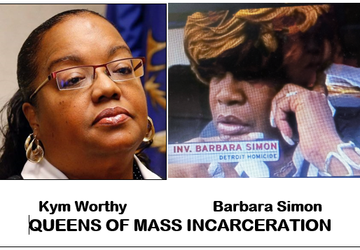
Notorious DPD Cop Barbara Simon involved in Sykes’ wrongful conviction

Tyrone Deshawn Moore’s affidavit (excerpt):
“If the police claim that I gave them a statement regarding the events surrounding an incident that happened at Page’s Bar, those statements are fabricated because I didn’t see a crime. I never signed any witness statements; the only documents I recall signing were the property release forms.

On April 3, 2024, I was shown a police statement that has the signature of the name Tyrone Moore signed at the bottom and dated for January 11, 2002, and January 11, 2002, and neither are my signatures. I never saw Mr. Sykes shooting; I didn’t see him armed with a weapon and didn’t see an AK assault rifle lying on the floor of a van.

Detective Barbara Simmons [sic]
told me that Mr. Sykes was in the bar, and she kept asking me about Tony Davis. I never told any detectives that I went to the bar with Mr. Sykes or that I saw him shooting a gun. Detective Simons [sic] (and other Detectives) never really asked me if I heard or saw anything from that night. Instead, Detective Simons [sic] told me what happened and tried coercing me to agree with their scenario. Any witness statements in connection with Mr. Sykes’ case that purport to be my signature are forged.”

e

