[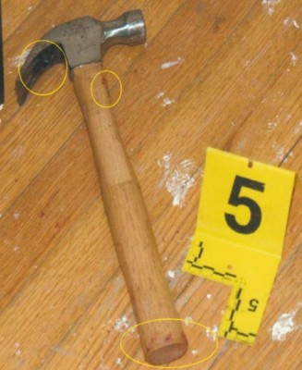](http://voiceofdetroit.net/wp-content/uploads/TKhammer.jpg)

**OFC. DARELL FITZGERALD**

**SWORN DEPOSITION 11/16/18**

**Q: Did you ever see Terrance Kellom with a hammer in his hand.**

**A. No.**

**A. [He] was on his knees when I saw him.**

**Q. Okay. And when he was on his knees, did you see him holding anything?**

**A. No. I did not.**

**Q. And did you see him fall forward.**

**A. Yes.**

**Q. To the ground?**

**A. Yes I did.**

**Q. Okay. Now after you seen him fall forward to the ground, did you see anything in his hands then?**

**A. No, I didn’t..**

**Q. Or anything near his hand?**

**A. No.**

**Q. Did you see any hammer that evening at the house?**

**A. No.**

**\*\*\*\*\*\*\*\*\*\*\*\*\*\*\*\*\*\*\*\*\*\*\*\*\*\*\*\*\*\*\*\*\*\*\*\*\*\*\*\*\*\*\*\*\*\*\***

**SWORN TESTIMONY 10/24/2019**

***Heard cop upstairs yell, “Put down the hammer, I’m not going to shoot you.”***

***Kevin Kellom and Mitchell Quinn began running upstairs.***

***Heard loud banging like hammering, heard Kellom fall to 1st floor.***

***Had confrontation with Kevin Kellom***

***Volley of gunshots In downstairs hallway; DID NOT SEE KELLOM AT ALL DURING SHOOTING, WITH OR WITHOUT HAMMER, despite direct proximity***

***Left scene briefly after Kellom killed, came back and saw hammer then.***

Q