Juvenile lifer Anthony Jones may one day walk but fate of others left unanswered

Published: Tuesday, February 07, 2012, 2:38 PM Updated: Tuesday, February 07, 2012, 3:43 PM
By John Barnes | jbarnes1@mlive.com
Follow
4

close
DiggStumble UponFarkReddit
Share Email Print
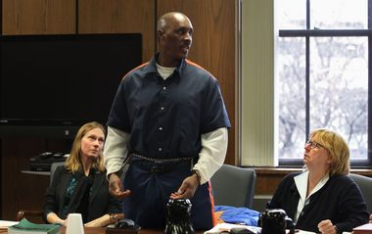Kalamazoo GazetteAnthony Shamont Jones apologizes to Karen Hermanns-Meier, daughter of Ronald Hermanns, during his resentencing hearing allowing possible parole. Jones was 17 when he was sentenced to life without chance of parole in a case involving the shooting death of a Kalamazoo grocery store owner, Ronald Hermanns. Jones' attorneys are left, Kimberly Thomas, and Deborah A. LaBelle, right.
When Michigan “juvenile lifer” Anthony Jones was resentenced this week, he was given the chance to some day go free in the 1979 death of a store owner.
But because the unprecedented decision that lifted Jones' life-without-parole sentence will not be challenged, the question of whether other juvenile lifers deserve similar reconsideration -- or not -- is left unanswered.
Avoiding that possibility had no bearing on the decision not to appeal, assistant Kalamazoo County Prosecutor Heather Bergmann said. That Jones, 50, received a more severe sentence when he was 17 than the teen who pulled the trigger did, Bergmann said.
“We were unaware of all that history when we first took on the case,” she said. “We're happy with the result. We believe it's fair.”
Michigan has more juvenile lifers than almost any other state, an issue that was the focus of an MLive Media Group investigation in November. Like Jones, approximately one-third of the more than 350 inmates serving mandatory life for crimes at 17 and younger did not do the actual killing.
A Kalamazoo County judge on Thursday cited that fact in resentencing Jones to a parolable life term. Jones' lawyers say it was the first ruling of its kind since the U.S. Supreme Court in 2010 said “natural life” sentences for juveniles in non-homicide cases is unconstitutional.
Whether that includes “felony murder” convictions – where a person involved in any aspect of a crime can be treated as guilty as if they pulled the trigger – remains unanswered. Circuit court decisions are not binding statewide; that is the domain of higher courts.
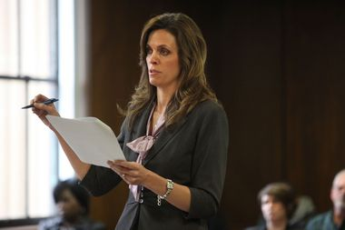Kalamazoo GazetteAssistant Prosecutor Heather Bergmann, shown during the resentencing proceeding for Anthony Shamont Jones, says fairness to Jones weighed in the decision not to appeal.
Such was the case with Jones, who planned and participated in the robbery of Lesman's Market in Kalamazoo on Jan. 4, 1979. Testimony showed he struck the store's owner but fled when the altercation escalated and 15-year-old Anthony Dunigan fatally shot store owner Ronald Hermanns.
Jones was sentenced to life without parole for felony murder. Dunigan was tried as an adult and received a pardonable life term for the lesser charge of second-degree. He remains in prison. Two others, 14 and 16, remained in the juvenile system and were later freed.
Bergmann, the prosecutor, believes Jones' resentencing order would have been overturned on appeal. If not, she believes very few juvenile lifers would have benefited. Jones' case involves legal nuances in which malicious intent – an important consideration in homicide cases - did not have to be proved. That would not exist for those convicted of felony murder after 1980, she said.
Still, Bergmann said, “We chose not to appeal on an equitable basis.”
Jones' lawyer, Deborah LaBelle, represents many of the state's juvenile lifers. See too was pleased with the outcome of the Jones case. “We are all trying to do justice here.”
Regardless, the larger issue could be settled this year. The U.S. Supreme Court in March will hear oral arguments on whether life without parole for juveniles is unconstitutional even in homicide cases.
The two cases at issue involve 14-year-olds, though the court could expand its ruling to all minors 17 and younger. That's what it did in the 2010 ruling and in 2005, when it outlawed capital punishment for juveniles.
Both times, in 5-4 rulings, the court found emerging science shows juveniles have lesser culpability due to lack of maturity, an undeveloped sense of responsibility, and increased vulnerability to peer pressure and adult influence.
A ruling in the current cases before the high court is expected by the end of June.
-- Statewide projects coordinator John Barnes oversaw MLive Media Group's November investigation into Michigan's high number of juvenile lifers. Email him at jbarnes1@mlive.com and follow him on Twitter.

