Police gave high fives made fun of suspect after violent arrest in Inkster, attorney says
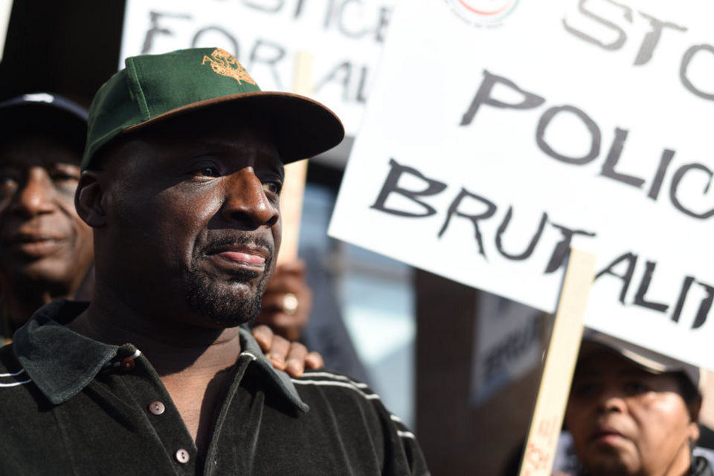
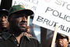
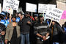
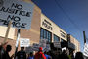
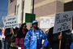
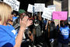
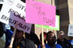
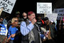
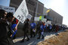
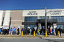
1 / 16

Floyd Dent listens to speakers at a rally in his support outside the Inkster Police Department Wednesday, April 1, 2015. Inkster police are facing an investigation into their handling of a Jan. 28 traffic stop that hospitalized 57-year-old Floyd Dent of Detroit. Dent was eventually charged with resisting and assaulting police and possession of cocaine, which Dent claims was planted. The charges of resisting and assaulting police was dismissed, but Dent, who has no criminal history based on Wayne County Records, was arraigned for cocaine possession Wednesday morning. Wayne County Circuit Judge David Groner, entered a not-guilty plea on Dent's behalf. The stop is being investigated by state police. (Tanya Moutzalias | MLive Detroit)
Tanya Moutzalias | tmoutzal@mlive.com
Print Email
By Gus Burns | fburns@mlive.com
Follow on Twitter
on April 02, 2015 at 7:30 AM, updated April 02, 2015 at 7:33 AM
0
Reddit

Email

Floyd Dent arrest
- Police gave high-fives, made fun of suspect after violent arrest in Inkster, attorney says
- Attorney for man beaten during Inkster arrest: 'We're not anti cop, we're anti Robocop'
- Former chief rips Inkster Police Department for 'too many bad apples'
- Video of man beaten during Inkster traffic stop sparks state police investigation
- Protests planned after video of Inkster police beating man during traffic stop surfaces

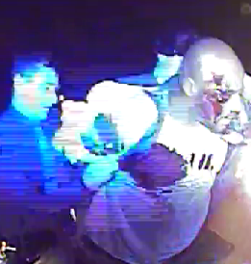Screenshot from Jan. 28 arrest video.Gus Burns | fburns@mlive.com
INKSTER, MI -- A Wayne County Judge's order to present Floyd Dent's mugshot and booking video was delivered to the Inkster Police Department Wednesday. A protest followed.
"We will stand until these officers are gone out of this police department," Rev. Charles Williams II, president of the Detroit chapter of the Al Sharpton-founded National Action Network said into a megaphone from the front steps.
Floyd, family members and 50-plus supporters cheered.
Dent, 57, of Detroit, is the subject of a violent arrest caught on police dash-cam video Jan. 28. Footage shows Dent pulled from his 2011 tan Cadillac after police reports say he committed multiple traffic violations and appeared to be evading police.
- Dent arrest video
He'd just left a motel frequented by drug dealers and prostitutes, police reports say. Dent said he was delivering a bottle of alcohol to a friend.
Inkster Police Officer William Melendez, who previously worked for the Detroit Police Department and has been named in numerous lawsuits and nicknamed "Robocop" by some members of the public, is seen in the video choking and punching Dent in the head 16 times. Another officer then shocked Dent with a Taser three times, police reports say.
Dent refused to show officers his right hand when they approached his car and said, "I'll kill you," Melendez wrote in his incident report. Melendez writes that Dent bit him, and said, "I'll bite you again," just before Melendez delivered the flurry of punches that left Dent bloody and led to a three-day hospital stay.
Dent's Novi-based attorney, Gregory Rohl, claims the Department has been withholding evidence that's usually provided as part of standard procedure.
"It looks terrible for them," Rohl said. "From what (Dent) remembers about what happened in there, they were doing high-fives and stuff behind him, making fun of him.
"And then his mugshot, it's just -- think about it, think about how he appeared in the back of that car -- and they don't want to give that up. And they don't want to give up all the names of everyone because they know I'm going to call them on it."
Rohl believes nine to 11 officers were on scene, though he's only been able to identify four.
- Ex-Inkster chief says department has 'bad apples'
Wayne County Circuit Judge David Groner on Wednesday ordered the Inkster Police Department make public the booking video, names of officers at the scene, mugshots, evidence photos, dispatch records and reports produced in connection with the arrest.
Dent is charged with possession of cocaine, which he and his attorney claim was planted.
Rohl says Dent, who denies having crack cocaine or making the statements in Melendez's report, submitted to and passed a lie detector test, the results of which have been turned over to the Wayne County Prosecutor's Office for review.
Rohl on Wednesday said he expects to receive the evidence within 48 hours.
Inkster police remained inside the headquarters throughout Wednesday's protest.
"I appreciate everybody's First Amendment rights," Inkster Police Chief Vicki Yost said. "What they have to say matters and I want to be clear on that ... "
She encouraged patience and says internal investigation and state police investigations are ongoing.
"We started the internal investigation without any complaint from Mr. Dent, and we'll conclude it," Yost said. "We'll follow the facts and we'll take the appropriate action.
Rally for Floyd Dent, Detroit man beaten during traffic stop in InksterFloyd Dent, 57, was beaten during a traffic stop in Inkster on Jan. 28. Supporters joined Dent for a rally in front of the Inkster Police Department April 1, 2015. Many in attendance are demanding the main officer involved, William Melendez, nicknamed "Robocop" by the public, be fires and charged criminally. State police are currently investigating.
"Our investigation was started immediately when I was notified that there was a serious use of force and there was a subject who was injured."
Rohl said state police weren't notified until after his office issued a public statement about the arrest last week. He hopes the Department of Justice will perform an investigation of their own.
Melendez, in addition to being an Inkster police officer, is a part-time Highland Park detective and listed as the CEO of Dearborn-based Strategic Security, a private security and firearms training company.
He's currently on desk duty with the Inkster Police Department.
Yost, who retired early from the Detroit Police Department and was named Inkster's chief in August, said department policy allows secondary employment. She wouldn't confirm when Melendez was hired and didn't know offhand how many hours policy allows officers to dedicate to other jobs.
Melendez has been involved in numerous prior lawsuits alleging civil rights violations.
In an open federal lawsuit stemming from a July 26, 2011 raid in Inkster, DeShawn Acklin is suing the city and seven officers, including Melendez. Acklin claims he visited a home targeted in a raid conducted by Detroit police. Acklin was using the bathroom when police "barged into the house," the complaint says.
The lawsuit says Acklin complied with officers' orders, dropped to the floor and was subsequently choked and beaten unconscious. Inkster police detained Acklin for three days before releasing him from jail. He was never charged with any crimes.
- DeShawn Acklin V. Inkster, Melendez.pdf
Another lawsuit naming Melendez involved the killing of Ernest Crutchfield II. The lawsuit, filed by the victim's son and eventually settled by Detroit for $50,000, claims Melendez and other officers raided Crutchfield's home in November 2003 without a warrant and fatally shot the man.
Melendez was indicted along with 16 fellow Detroit police officers in 2003 stemming from claims they planted evidence, falsified reports and stole cash and property from suspects. A jury acquitted the officers in that case.
Dent is scheduled to return to court April 15 at 9:30 a.m. for a docket hearing on his cocaine possession charge.
Another rally in support of Dent is planned for 10 a.m. Friday. Protesters plan to march from the site of his arrest, near the former Inkster police headquarters, 27301 S. River Park in Inkster, to the new headquarters, 26279 Michigan in Inkster.

