VOICE OF DETROIT http://voiceofdetroit.net
Editor, Reporter Diane Bukowski, P.O. Box 32684 Detroit, MI 48232
Direct Line: 313-825-6126 Direct Fax: 313-557-1576 email: diane_bukowski@hotmail.com

SEAN COX RIGHT-WING AFFILIATIONS
September 14, 2011

Former Pres. George W. Bush, who put Sean Cox on the federal bench, is also a member of the international cartel The Carlyle Group, parent company of Synagro; Cox cites the Synagro scandal at DWSD as one of the reasons for its takeover
FROM “MONEY TRAILS TO THE FEDERAL BENCH”
Michigan: U.S. District Court Judge Sean Cox
U.S. District Court, Eastern District of Michigan
Nominated: September 10, 2004 | Confirmed: June 8, 2006
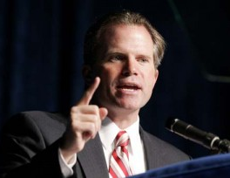
Summary: Cox contributed $2,000 to Bush in December 2003 while he was a state judge. Cox gave $790 in statecampaign contributions after his nomination, including $500 to the campaign of his brother, Michigan Attorney General Mike Cox, according to state records. He also gave nearly $5,500 in federal contributions to Republicans between 1993-2002, including $3,000 to former Sen. Spencer Abraham.
Sean Cox is the brother of former Michigan AG Mike Cox, at left, who was the only Republican to OPENLY endorse the racist anti-affirmative aciton Proposal 2; he used his office (although others supported it behind closed doors); he used his office to ensure its placement on the ballot.
Chronology:
• Sept. 10, 2004: Bush nominates Cox.
• Oct. 25, 2004: Local Republican committee receives $200 from Cox.
• Feb. 14, 2005: Bush re-nominates Cox.
• April 4, 2005: Local Republican committee receives $90 from Cox.
• Dec. 1, 2005: Cox’s brother, Michigan’s attorney general, receives $500 from Cox.
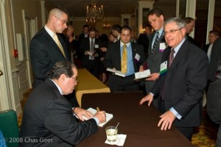
FROM RIGHT WING WATCH:
Sean Cox is a member of the ultra-right-wing Federalist Society.
Federalist Society for Law and Public Policy Studies
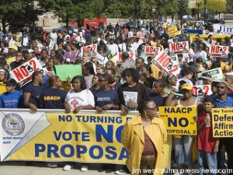
Established: 1982 by a group of right-wing law students President/Executive Director: Eugene Meyer Justice Antonin Scalia signs copy of U.S.
Board of Directors: National Co-Chairmen Constitution at Federalist Society Lawyers.Prof. Steven Calabresi and David Convention in 2008, at right M. MacIntosh, Directors Prof. Gary Lawson, and Eugene B. Meyer, Hon. T. Kenneth Cribb (President of Collegiate Network), and Mr. Brent O. Hatch, treasurer.
Membership: The FS Lawyers Division has 25,000 legal professionals; Student Division has more than 5,000 law students at 145 law schools; 60 metropolitan lawyers’ chapters; 15 nationwide practice groups; and a new Faculty Division with unpublished membership numbers.
Finances: $5,450,536 (total revenue for 2004)
Grants: Since 1985, The Federalist Society has received over $12 million in grants from conservative foundations, such as the Earhart, Bradley, Simon, and Olin Foundations, as well as the Carthage, Koch, and Scaife Foundations.
Publications: Several e-mail newsletters on different topics, a quarterly law journal, a “Conservative and Libertarian Pre-Law Reading List,” and various reports on legal issues.
Read the latest news on the Federalist Society on the group’s Right Wing Watch index page

NAACP March(left) against racist Proposal 2, an example of initiatives supported by the Federalist Society
Principal Issues
- The Federalist Society hopes to transform the American legal system by developing and promoting far-right positions and influencing who will become judges, top government officials, and decision-makers. FS is “dedicated to reforming the current legal order.”
- The Federalist Society is a well established network of right-wing lawyers, politicians, pundits, and judges.
- Many members of the Federalist Society advocate a rollback of civil rights measures, reproductive choice, labor and employment regulations, and environmental protections.
In Federalist Society’s guide to forming and running a chapter of the society, FS says it “creates an informal network of people with shared views which can provide assistance in job placement.”
- The Federalist Society has 15 different “practice groups” that focus on particular legal issues, such as civil rights and labor and employment law.
Read PFAW Foundation’s detailed report, The Federalist Society: From Obscurity to Power [PDF file].
Its members include, among numerous others:
Federalist Society Members in the Bush Administration [partial list]
Former Attorney General John Ashcroft
Former Secretary of the Department of Energy Spencer Abraham
Former Solicitor of Labor Eugene Scalia (Supreme Court Justice Antonin Scalia’s son)
Federal Judicial Nominees
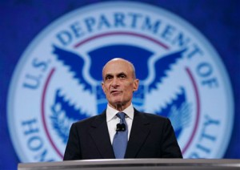
Samuel Alito, confirmed to the U.S. Supreme Court
John Roberts, confirmed to the U.S. Supreme Court

Michael Chertoff, confirmed to the U.S. Court of Appeals for the Third Circuit, currently Secretary of the Department of Homeland Security
Henry Saad, nominated to the U.S. Court of Appeals for the Sixth Circuit [withdrawn]
Susan Neilson, confirmed to the U.S. Court of Appeals for the Sixth Circuit Michael Chertoff, Dept. Homeland Security
Deborah Cook, confirmed to the U.S. Court of Appeals for the Sixth Circuit
Jeffrey Sutton, confirmed to the U.S. Court of Appeals for the Sixth Circuit
Other High-Profile Federalist Society Members [partial list]
- Justice Antonin Scalia, U.S. Supreme Court
- Senator Orrin Hatch(R-Utah)
- Charles Murray, controversial author who asserted that some races are inherently less intelligent than others
- Don Hodel, former Christian Coalition president
- Former Michigan Governor John Engler
- Former Michigan Supreme Court Justice Maura Corrigan; currently head of the Michigan Department of Human Services, which is about to slash 15,000 families from the public assistance rolls, and is steadily kidnapping poor children, particularly in the Black and Latin communities, from their families for profit through Child Protective Services.
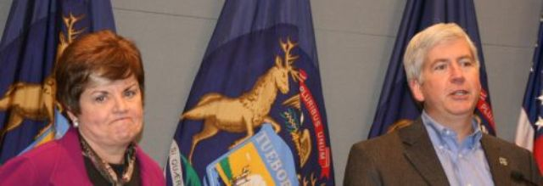
Maura Corrigan and Rick Snyder plotting to kidnap more poor babies and starve the rest

