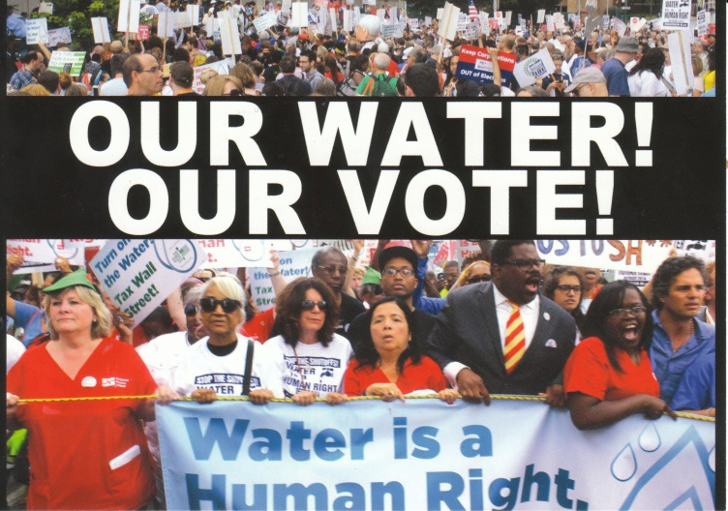
STOP THE THEFT OF OUR WATER SYSTEM
Detroit’s Largest Asset!
THE PEOPLE HAVE A RIGHT TO VOTE!
#OurWaterOurVote

On June 12, 2015, the “City of Detroit” signed a contract with “The Great Lakes Water Authority.” It “leases” the nation’s third largest public municipal water and sewerage department, (DWSD) to an unelected regional authority imposed by Detroit’s unelected former Emergency Manager Kevyn Orr, appointee of Michigan Gov. Rick Snyder, under the unconstitutional Detroit Bankruptcy plan.

But THE CONTRACT ALLOWS DETROITERS TO HOLD A REFERENDUM VOTE ON IT, under PA 233 of 1955. A total of 15,000 petition signatures are required. PETITION CIRCULATORS DO NOT HAVE TO BE RESIDENTS OF DETROIT.

“PA 233 of 1955, MCL 124.288 Sec. 8. (1) A municipality or Indian tribe desiring to enter into a contract with the authority under section 7 shall authorize, by resolution of its governing body, the execution of the contract. After the adoption of such a resolution by a municipality, the municipality shall publish a notice of the resolution in a newspaper of general circulation in the municipality. The notice shall state all of the following:
(a) That the governing body has adopted a resolution authorizing execution of the contract. (b) The purpose of the contract.
(c) The source of payment for the contractual obligation. (d) The right of referendum on the contract. (e) Other information that the municipality's governing body determines to be necessary to adequately inform all interested persons of the nature of the obligation.”

JOIN THE PETITION CAMPAIGN TO STOP THIS DISASTER FOR DETROIT AND THE COUNTIES OF WAYNE, OAKLAND, MACOMB, ST. CLAIR, LAPEER, GENESEE, WASHTENAW AND MONROE.

- BILL OF SALE: The contract is not a lease, but a “Bill of Sale” of DWSD personal property and its $6 billion in revenues, including retail revenues from Detroiters, to the GLWA.
- PRIVATIZATION: The Authority can sell DWSD real property, allowing privatization of the system. GLWA has an advisory contract with global water privatizer Veolia.
- REGIONAL RATES TO RISE: The Authority will set rates “to satisfy the Authority’s Revenue Requirement,” not limit them to 4% annually. The GLWA will greatly increase DWSD’s debt, to get contracts for cronies of board members. Debt payment is priority #1, not improvement of infrastructure, customer service, or water affordability.
- WATER SHUT-OFFS: DWSD’s water shut-offs will continue and may expand to the whole region. The GLWA Water Residential Assistance Program (WRAP) allows shut-offs, and does not base rates on income.
- TAX FORECLOSURES: The contract will attach Detroit water bills unpaid for six months to property taxes, and the GLWA could extend this practice throughout the six counties
- LOSS OF CITY OF DETROIT JOBS: Hundreds of experienced DWSD workers, particularly in the skilled trades, have already been laid off or terminated, creating on ongoing water quality crisis for the six counties.

TO WIN OUR CAMPAIGN FOR WATER FOR ALL, WE MUST FIRST DEFEAT THE GLWA, THEN DEAL WITH DWSD.

Sponsored by the COALITION TO SAVE DETROIT’S WATER & SEWERAGE DEPARTMENT #OurWaterOurVote

Endorsers to date: Detroit Active and Retired Employees Association (DAREA), The People’s Water Board, We the People of Detroit, Citizens for Detroit’s Future, Moratorium NOW!, Michigan Emergency Committee against War and Injustice, Baxter’s Beat Back the Bullies Brigade, StandupNOW, Russell Woods-Sullivan Neighborhood Association, Detroit Water Brigade
INITIAL CONTACT NUMBERS: 313-649-7018, 313-825-6126; email detroit2700plus@gmail.com, or tweet @wethepeopledet

