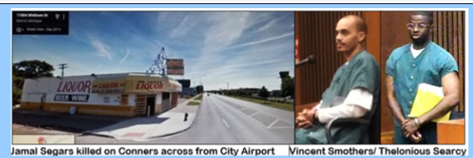

MICHIGAN COURT OF APPEALS No. 349169 Feb. 21, 2021
PEOPLE OF MI V. THELONIOUS DESHANE-EAR SEARCY

Court found trial judge Timothy Kenny abused his discretion in finding Vincent Smothers’ testimony not credible

“In sum, when considering the trial evidence in light of the other evidence that would be presented at retrial, we conclude that Searcy has a reasonably likely chance of acquittal. MCR 6.508(D)(3)(b)(i)(A). Therefore, the trial court abused its discretion by denying Searcy’s motion for relief from judgment with respect to Searcy’s claim of new evidence relating to Smothers.”

“On the first day of the hearing, Smothers testified that he murdered the murder victim on Conner Street “[n]ear the Detroit City Airport” on what he believed was September 6, 2004. Smothers noted that, although he initially intended to rob the murder victim, he decided to kill him “[a]s [he] got up to the back of the car.” Smothers testified in detail about the manner in which he and Daniels carried out the crimes and the manner in which they escaped from the scene. Smothers indicated that he decided to come forward when he learned that “somebody was locked up for” the September 2004 crimes. Smothers denied that he was promised anything in exchange for his testimony. Smothers also denied that he had “nothing to lose,” noting that he could be paroled in his lifetime

“. . . Smothers provided detailed testimony concerning the location of the crimes, the manner in which the crimes were carried out, and the weapons that were used. Smothers’s testimony that he approached the Corvette from behind and then began shooting is consistent with eyewitness testimony. The physical evidence also supports [his] testimony that he moved toward the driver’s side window, where he fired his gun once. Importantly, a bullet hole was located in “the side panel on the driver’s side,” and there were at least seven bullet holes in the Corvette. Furthermore, Dr. Schmidt testified at trial that there were gunshots to the back of the murder victim’s body, including one gunshot to the back of the head, and that the trajectory of the other shots “went from left to the right.”

“. . . Smothers testified at the hearing that the .40-caliber and .45-caliber handguns belonged to him and that he gave them to Daniels and told him to get rid of them. . . .Smothers testified that Daniels was his “associate[]” and that he had known Daniels for “several years.” Smothers also testified that he often gave murder weapons to others to keep because Smothers lived in “the suburbs.” Importantly, Searcy’s grandmother testified at trial that the .45-caliber gun that was associated with some of the casings found at the crime scene was brought into her apartment by Daniels.”

