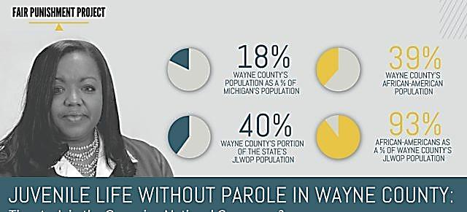

**JUSTICE DELAYED; WAYNE CO. PROSECUTOR WORTHY, FORMER MI STATE AG BILL SCHUETTE**

**OPPOSED SECOND CHANCES FOR JLWOPer’s**

Wayne Co. Prosecutor Kym Worthy testified twice before the Michigan State Legislature during the Second Chance campaign by families of the state’s juvenile lifers in the 2000’s.

Along with Oakland County Prosecutor Jessica Cooper and the Berrien County prosecutor, she expressed strong opposition to any changes in juvenile law that then required the imposition of LWOP for first-degree murder and other capital offenses.

But hundreds of family members and even victims of juvenile lifers flooded the State Capitol to support an end to JLWOP. Below, Second Chance families in 2006 during State hearings.

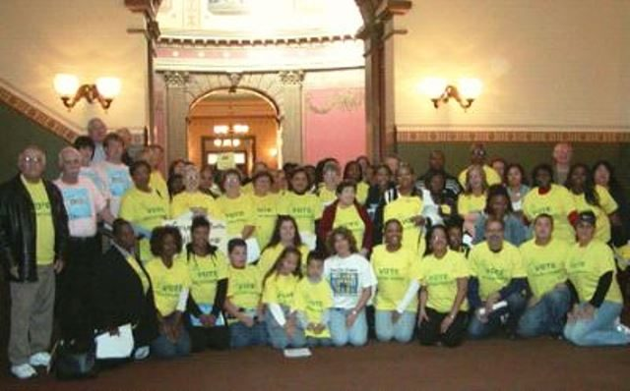

State AG Bill Schuette led national efforts to oppose the U.S. Supreme Court’s eventual decisions in *Miller v. Alabama* and *Montgomery v. Louisiana* which outlawed mandatory JLWOP nationally, except for the “rarest” child. Schuette filed amicus briefs on behalf of the state.

Now, Worthy has designated AP Tom Dawson to handle resentencing hearings. He says, “After carefully reviewing the 144 juvenile lifers convicted in Wayne County, the Wayne County Prosecutor’s Office agreed that 81 of them should be resentenced to a term of years. Seventy-nine of the 81 term-of-years juvenile lifers have been resentenced. Sentencing hearings for the Wayne County life-without-parole cases will begin in 2019.”

Dawson cites the 2018 Michigan State Supreme Court *Hyatt/Skinner* ruling that judges do not have to decide if an offender is “the rarest child” incapable of rehabilitation.